**Lovely Professional University**

INT-219



**Report on E-commerce website**

By:

Ansh Dhiman

11814548

Submitted to: - Ms. Ruchita Duggal

GitHub Link: -

**Contents Table**

|  |
| --- |
| **Project Overview**  Introduction.  What makes my project different?  Technologies used  Project description  Module overview. |
| **Module breakdown**  Functionality  Output  Code snippets |
| **Bibliography**  References  Video link |

**Project Overview**

**Introduction**

E-commerce websites serve a purpose of selling and buying products online. From the time e-commerce has come into play, it has completely changed the scenario of shopping, bringing the luxury of shopping anything from anywhere in the world to your tech-devices.

**What makes my project different?**

1. Simple user interface.
2. Highly Responsive website.
3. High code readability.
4. Reusable code.
5. Well-commented code.

**Technologies used**

HTML, CSS, JavaScript, jQuery, font-awesome icons. Google fonts.

**Project description**

So, I have made a simple, yet good looking website that includes all functionalities of a basic e-comm. website. It consists of a landing page, home page, navbars, login and registration forms validated using regular expression in JavaScript, products and its details, cart, navigation bar and footer implemented using Html, CSS and jQuery and JavaScript. User can visit any module by clicking on the hyperlinks in navbar. Website adjusts itself according to screen resolution, which is implemented using CSS.

**Modules Overview**

1. index.html – Home page of the website.
2. auth.html – landing page of the website consists of login and registration forms.
3. products.html – consists of all products.
4. product-details.html – consists of details of a product.
5. index.js – JavaScript file implements transitions.
6. style.css – CSS file of the whole project.
7. cart.html – shows products in cart and subtotal and total.
8. form.js – JavaScript files that handles forms and form validations.
9. Images folder – consists of all images used in the project.

**Module Breakdown**

**1. index.html**

1. Home page of the website.

2. Consists of navbar, featured contents, latest products, user reviews, offer, partner companies and footer as module parts.

Front-page: - consisting of navbar in top right and logo on top left.



Featured-products: - Consists of animation, when hover over an image it gets displaced some pixels upwards and then back on original position once mouse hover ends.

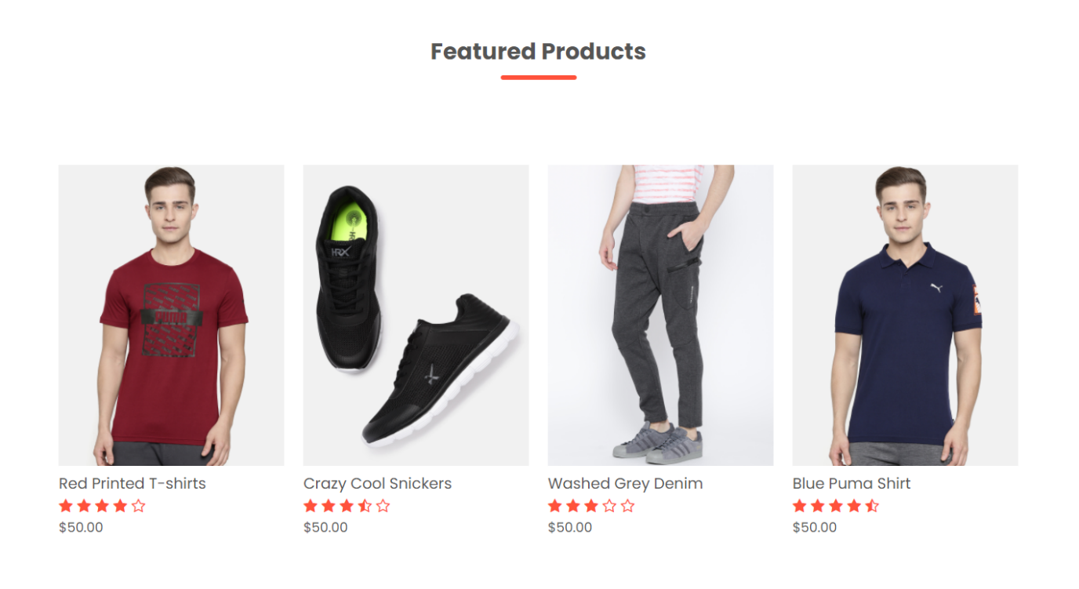

Code snippet of the transition: -

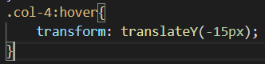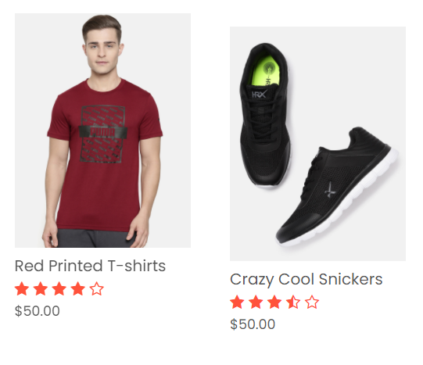

Latest Products: - Shows latest available products

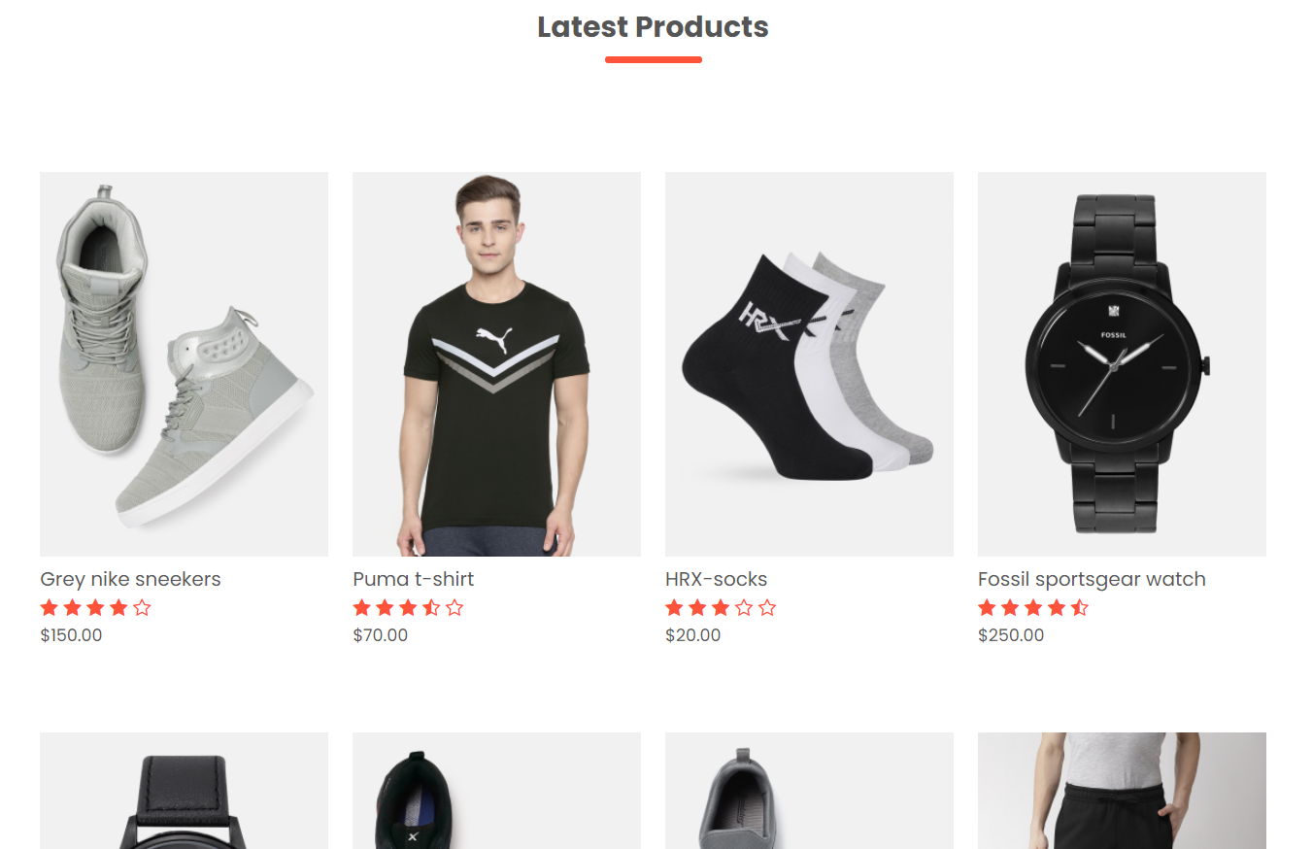

Code snippet: - of one of the above mentioned products in the image.

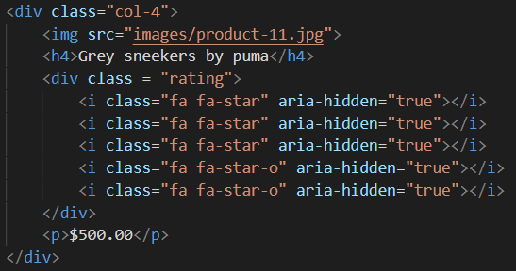

User reviews: - reviews given by users.



Footer: - consists of contact information and important links.

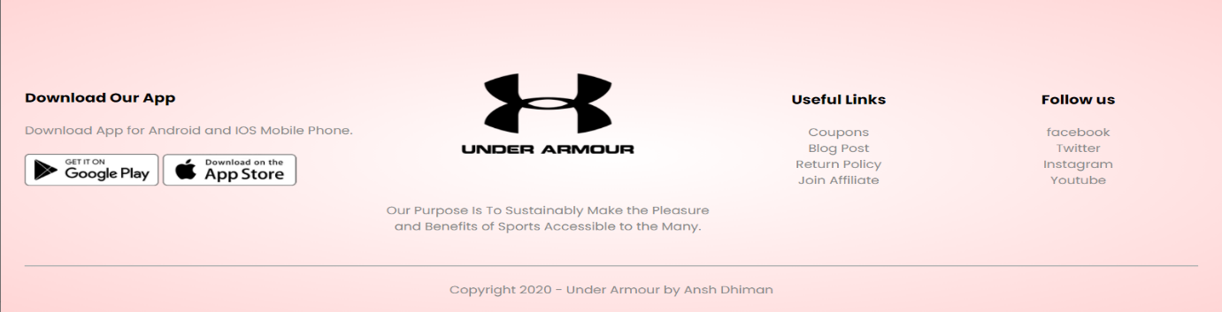

Code snippet of footer: -

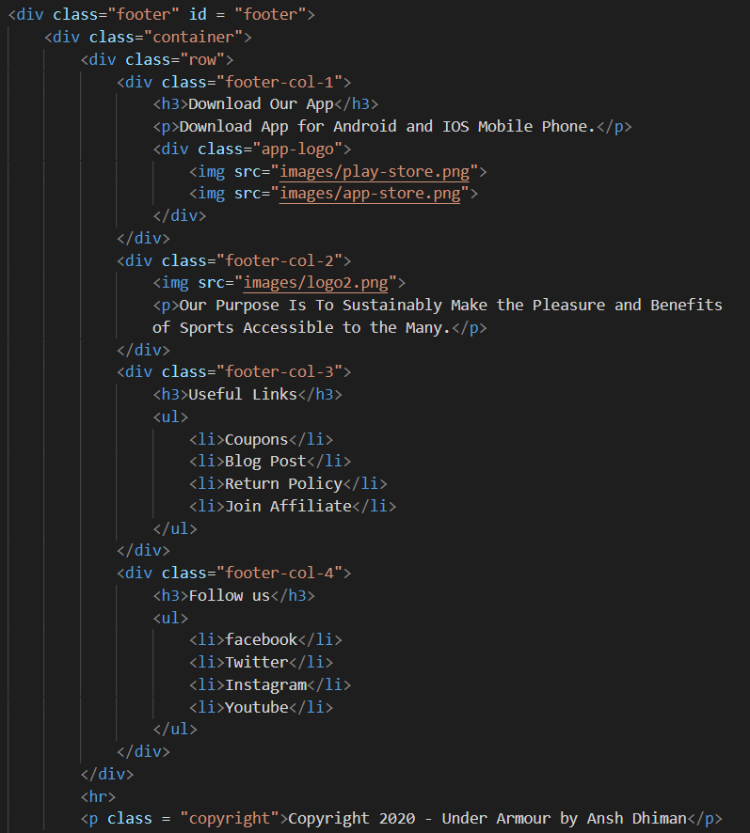

**2. products.html**

This file displays all products available on the website. And clicking on a product routes us to product-details.html page that displays product details.

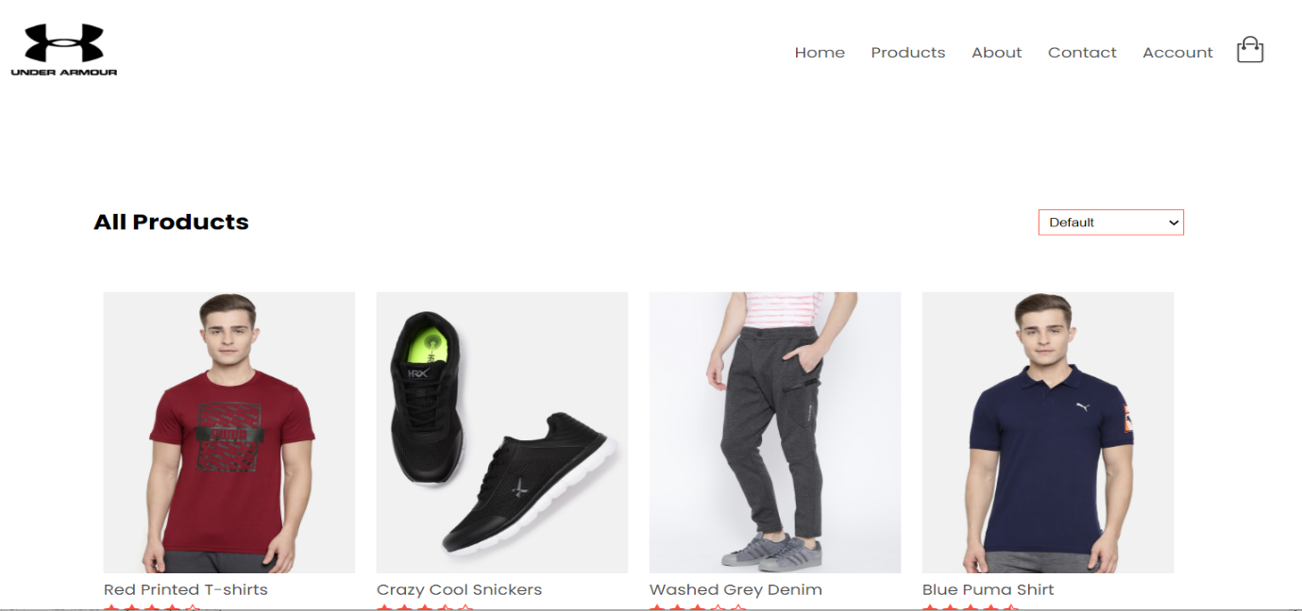

**3.** **product-details.html**

Clicking on products lead to product-details page that consists of relevant information of the product, similar images and add to cart option.

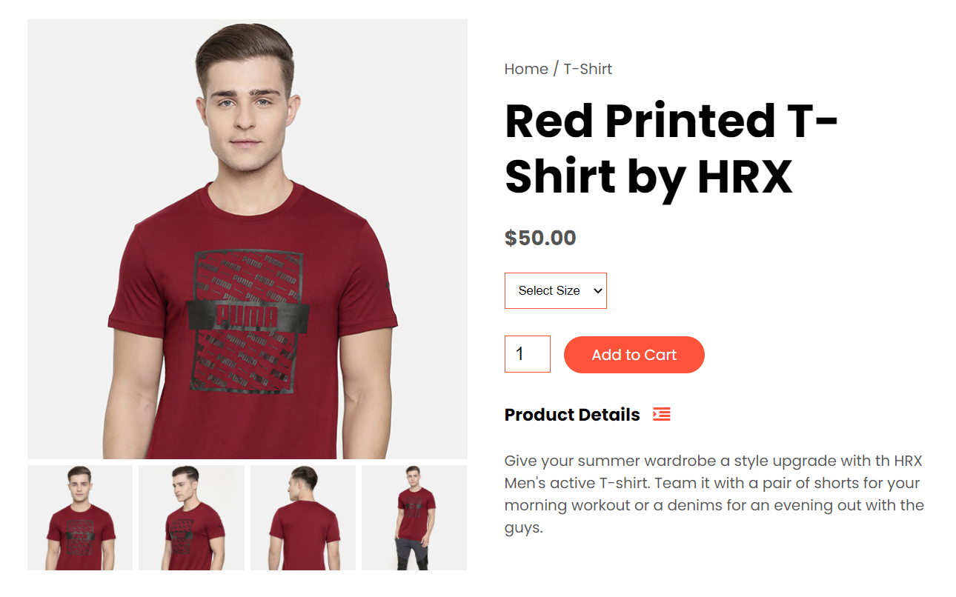

Clicking on the images below they get displayed in place of the bigger picture.

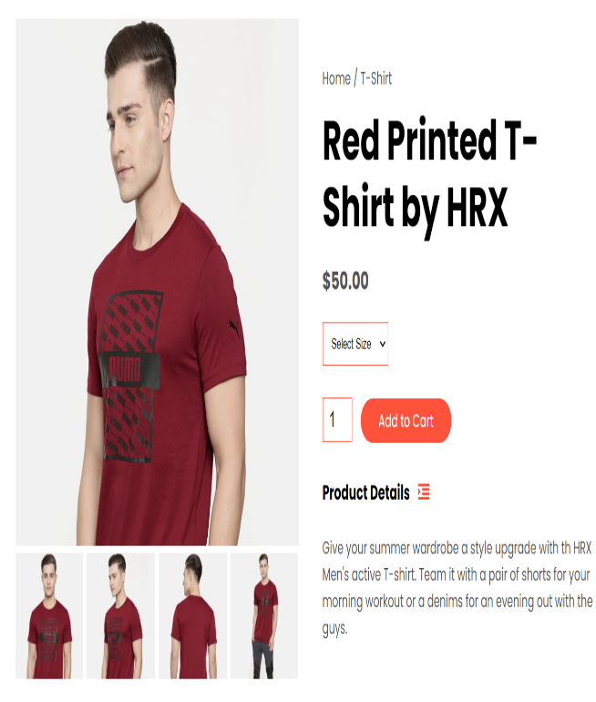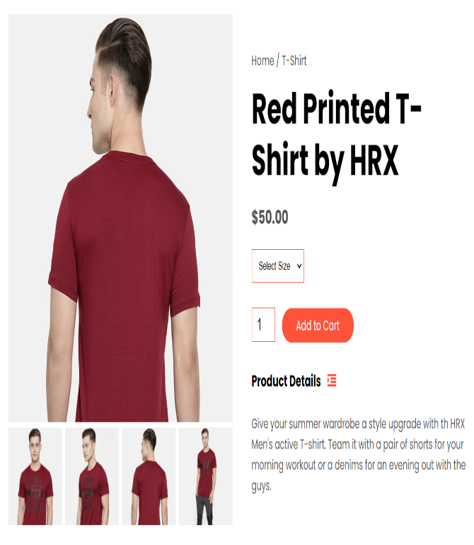

Code snippet of the same: -

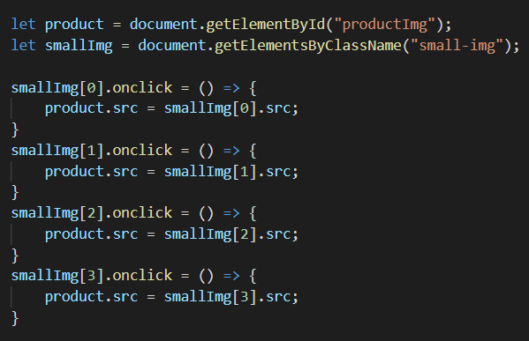

**4. cart.html**

Consists of information about which products are in the cart and in what amount, also tells about total price payable.

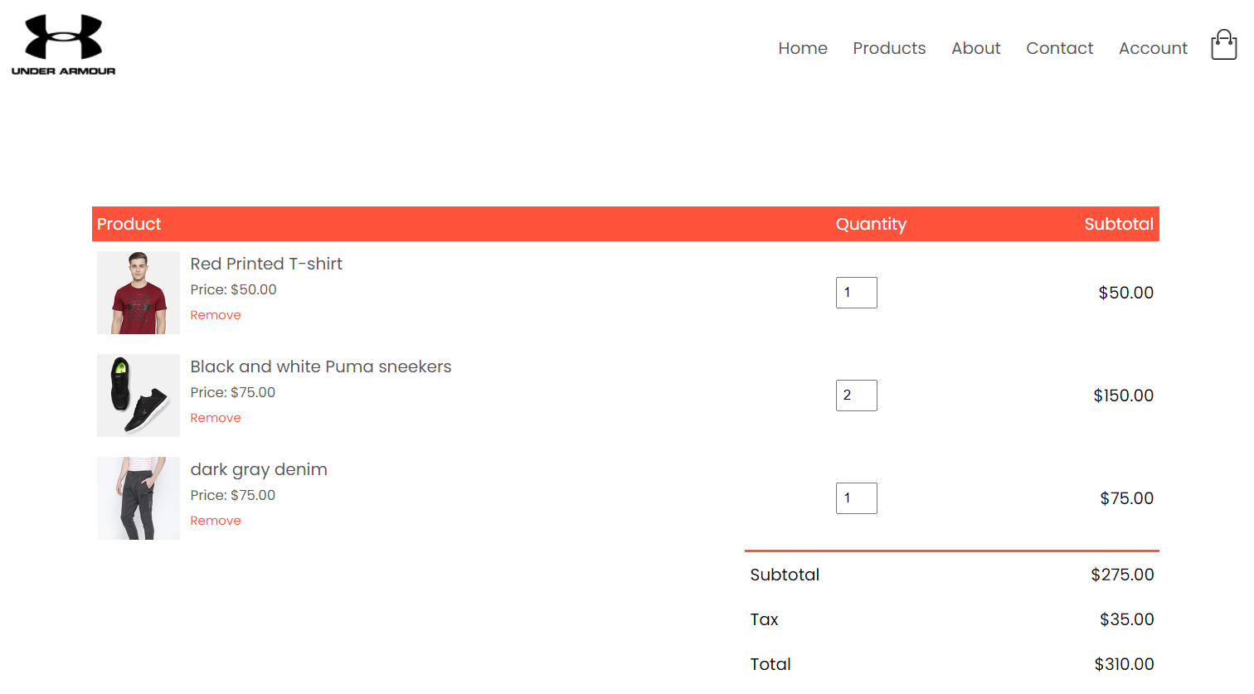

**5. auth.html**

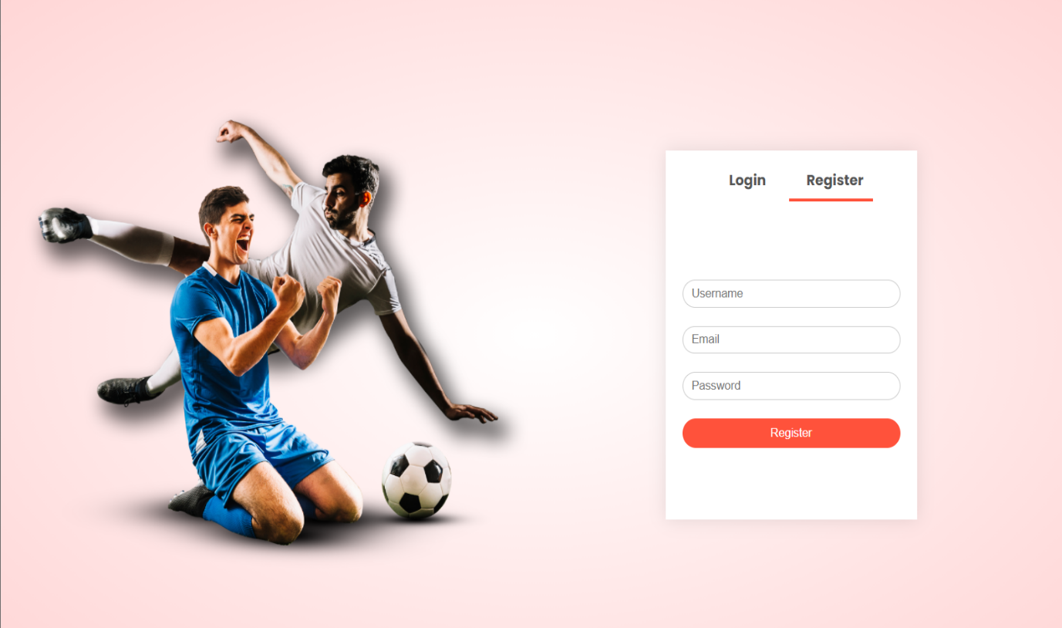Overview: consists of login and register forms.

On-clicking event gets triggered when we click on register or login in the above displayed image and relevant form gets displayed.

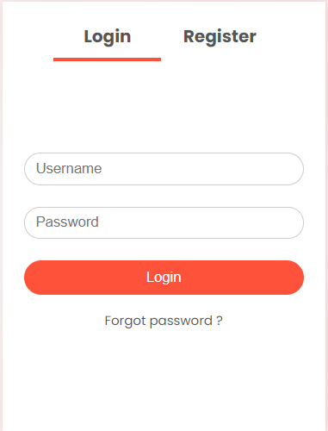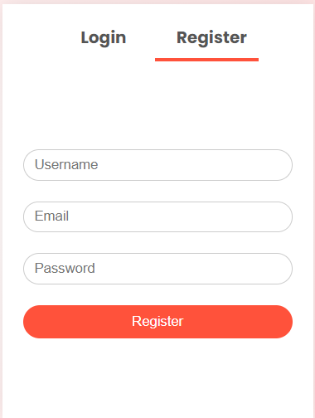

This transition happens due to underlying CSS and JavaScript.

Code snippet: -

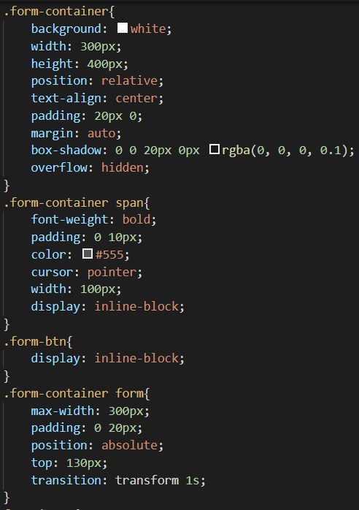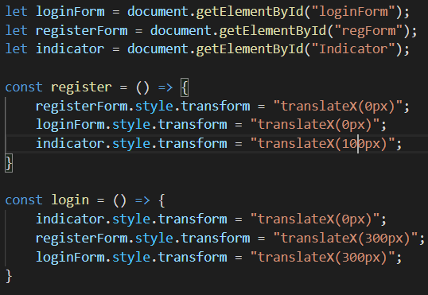

**6. style.css**

CSS file responsible for all beautiful UI and transitions and responsiveness of the website. All webpages are designed such that they adapt to all screen resolutions, using media queries of CSS.

In mobile view all the navbar disappears and all links come under one icon and instead of being in a single line on top because that would not look nice on screens with less resolutions.

Normal desktop view: -

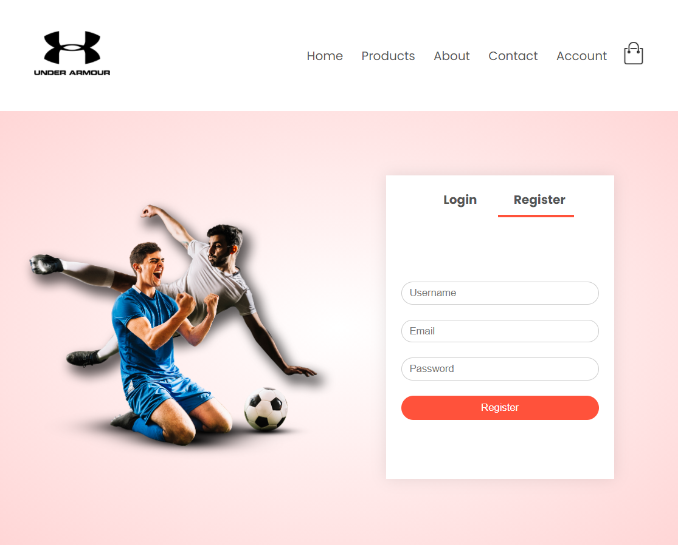

Mobile view: - Navbar gets shifted to icon besides cart icon.



Code snippets (CSS): -

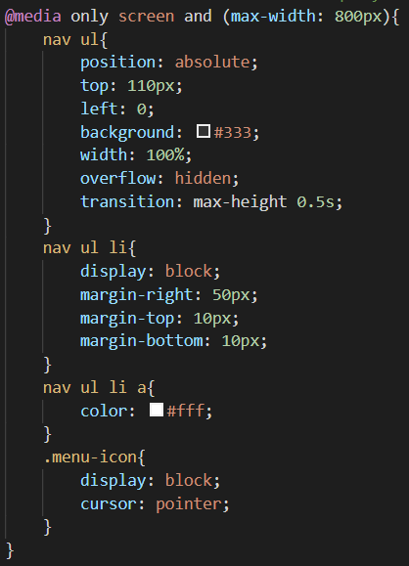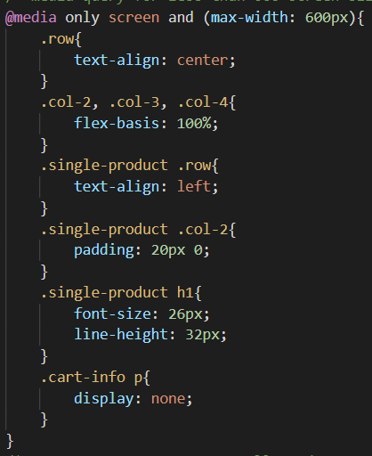

JavaScript: - Get the div with id “MenuItems” that consists of the navbar and check if maxHeight property is 0px then we have to set the height of the div to 200px that will contain all navbar links and vice-versa.

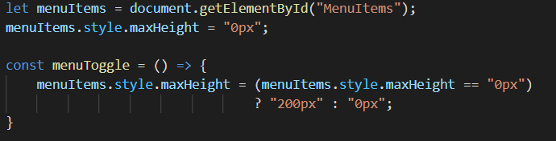

**7. index.js**

Consists of transition of navbar to menu-toggle. And displaying of images on-clicking event.

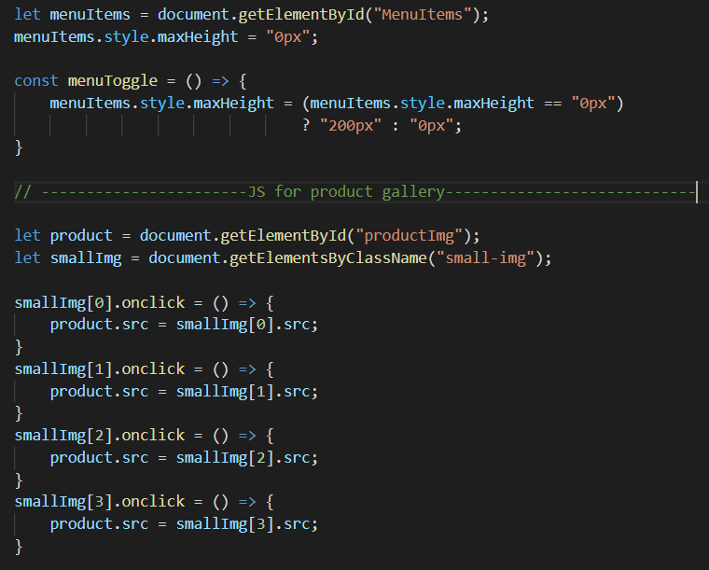

**8. form.js**

Used regular expressions for form validations and it also consists of transition code between login and registration form.

Transitions: -

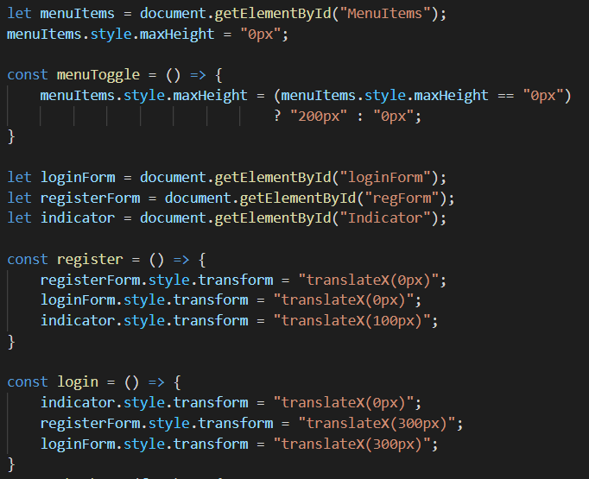

Form validation: -

HTML code: -

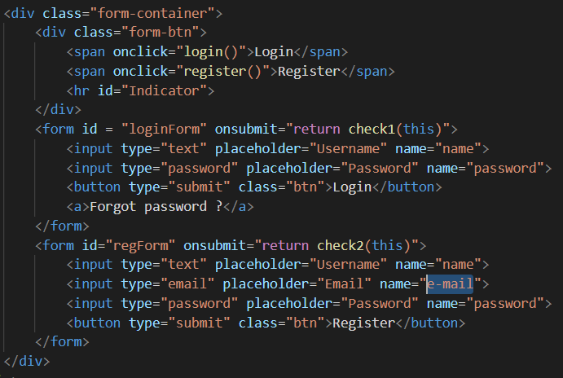

JavaScript code: -

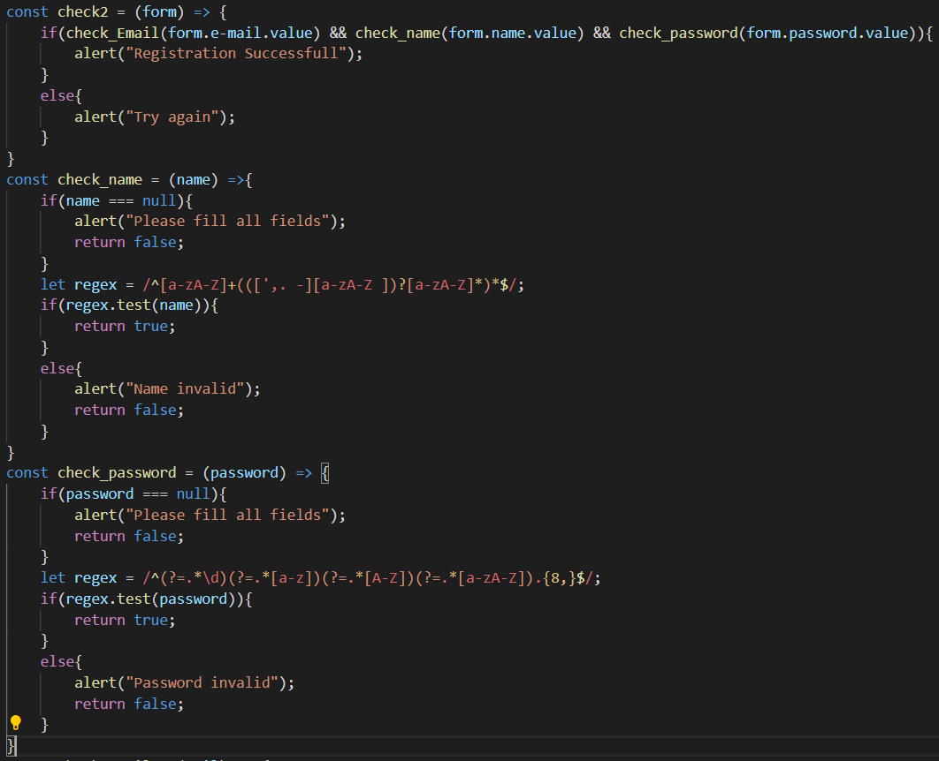

**Bibliography**

Some websites were really useful in completion of this project: -

1. GeeksForGeeks,
2. W3Schools.
3. YouTube.

Video link -